Containers

Contents

1. Container runtime 2

2. Anatomy of a Container 4

a. Linux Namespace 4

b. Linux Control Groups (CGROUPS) 6

# Container runtime

* A container runtime is a software component which works with operating system kernels and is responsible for both creating and running containers.

### **Creating Containers**

* **Image Handling**:
  + The container runtime pulls the necessary images from a registry (e.g., Docker Hub).
* **Container Creation**:
  + It takes the image and creates a container from it, setting up the necessary environment and filesystem for the container.

### **Running Containers**

* **Execution**:
  + The container runtime starts the container, executing the processes defined in the image.
* **Management**:
  + Manages the container’s lifecycle, including starting, stopping, and restarting containers as needed.
* **Resource Allocation**:
  + It handles resource allocation (CPU, memory, I/O) to ensure that containers run efficiently and remain isolated from one another.
* **Networking**:
  + Manages the network settings and configurations for containers.

### **Key Responsibilities of a Container Runtime**

1. Container Lifecycle Management
   * Create, start, stop, and delete containers.
   * Manage containerized processes.
2. Isolation
   * Set up namespaces and control groups (cgroups) for resource and process isolation (This we will see in the next section).
   * Ensure containers are sandboxed and cannot interfere with each other or the host.
3. Filesystem Management
   * Set up the container’s filesystem using techniques like union filesystems (e.g., OverlayFS).
   * Mount container-specific directories and manage filesystem changes.
4. Networking
   * Set up the container’s network stack (e.g., virtual Ethernet interfaces, bridges).
   * Handle container IP assignment and network isolation.
5. Interfacing with the Kernel
   * Use Linux kernel features like namespaces, cgroups, and capabilities to implement container functionalities.
6. Image Management
   * Pull container images from registries and unpack them.
   * Layer and prepare the image as a container-ready filesystem.

# Anatomy of a Container

* A container is composed of:

1. Linux Namespace
2. 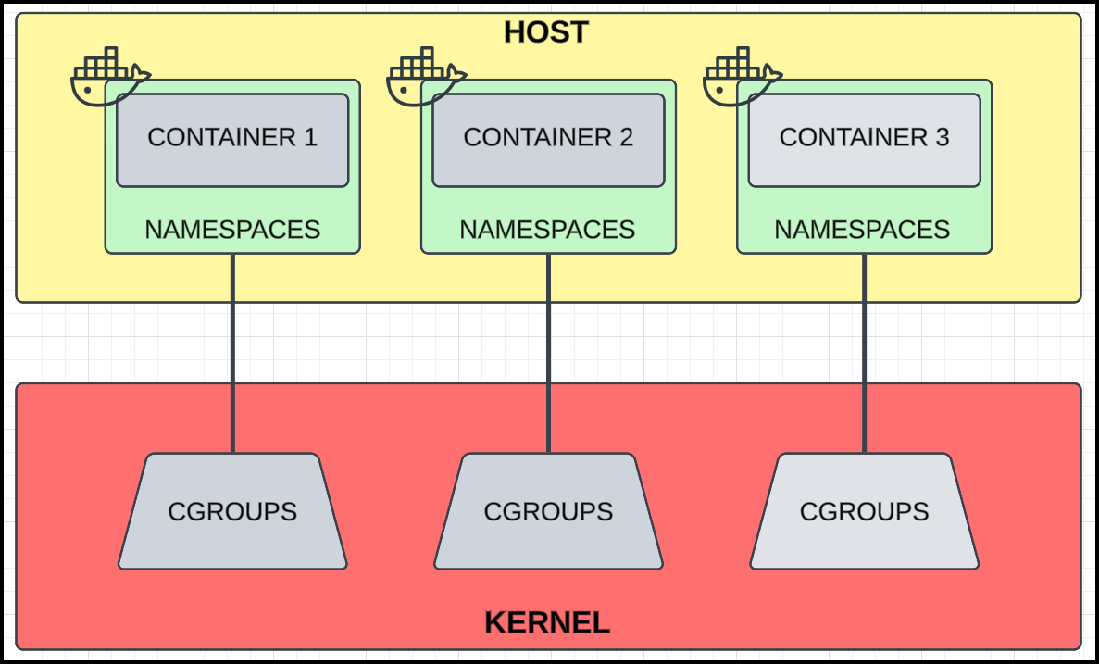Linux Control Group (CGROUPS)

## Linux Namespace

* A **namespace** is a mechanism provided by the Linux kernel to create isolated environments.
* Processes running in a namespace perceive a restricted or virtualized view of system resources. This allows an application to think it has access to the entire file system and hardware, even if it's restricted.
  + For example, an app can run as a superuser but actually only access a limited file system as a specific user.

### Types of Namespaces

|  |  |  |
| --- | --- | --- |
| **Namespace Type** | **Description** | **Use in Containers** |
| **PID** (Process ID) | Isolates process IDs. Each container has its own process ID space, so the processes inside a container don’t see or interfere with processes in other containers or the host. | Ensures that processes inside a container only see other processes in the same container. |
| **NET** (Network) | Isolates network interfaces, IP addresses, routing tables, ports, etc. | Allows containers to have their own network stack, virtual interfaces, and IP addresses. Containers can be networked together or isolated. |
| **MNT** (Mount) | Isolates the filesystem mount points. | Provides each container with its own view of the filesystem, typically mapped to a specific directory on the host. |
| **UTS** (Unix Timesharing System) | Isolates hostname and domain name. | Enables containers to have their own hostname and domain name. |
| **IPC** (Inter-Process Communication) | Isolates IPC resources like shared memory and message queues. | Prevents interference in IPC mechanisms between containers or between containers and the host. |
| **USER** (User) | Isolates user and group IDs. | Allows mapping container users to host users (e.g., root in the container may map to a non-root user on the host). |
| **CGROUP** (Control Group) | Not technically a namespace, but often used alongside namespaces to control resource allocation (CPU, memory, etc.). | Ensures containers use only their allocated resources. |
| **TIME** | Ability to change time. | NA |

Note: Docker uses all namespaces **except** the **TIME** namespace (time cannot be changed in Docker containers).

### **How Namespaces Work in Containers**

* When a container is started (e.g., using Docker), the container runtime sets up namespaces for the container:
  + Each container gets its own **isolated view** of the resources specified by the namespace types.
  + For instance, a container’s **PID namespace** means the container can have its own set of process IDs starting from 1, while being unaware of processes on the host or in other containers.
  + Similarly, a **NET namespace** ensures that each container has its own network stack, which can be bridged, NATed, or even directly exposed to the host network.

## Linux Control Groups (CGROUPS)

* Control groups are another Linux kernel feature that restricts how much hardware each process can use.
* Docker uses cgroups to:
  + Monitor and restrict **CPU usage**.
  + Monitor and restrict **network and disk bandwidth**.
  + Monitor and restrict **memory consumption**.
* Benefits:
  + Prevents resource-hogging containers from affecting others.
  + Avoids significant memory partitioning as seen with virtual machines.
* **Limitation**: Control groups cannot assign disk quotas to containers. However, container-native storage solutions can address this.

### Isolation Mechanism

* **Namespaces**: Provide isolation by exposing different system views to each container.
* **Control Groups**: Provide resource isolation by restricting hardware usage.

### Caveats

* **Linux-Only Features**
  + Control groups and namespaces are native to Linux, meaning Docker runs natively on Linux and some newer versions of Windows.
* **Kernel Dependency**
  + Containers can run on any system, but container images are tied to the kernel they were created from.
  + Containers created from Linux-configured images can only run on Linux, and those from Windows-configured images can only run on Windows.
* To run Docker on Windows, you typically need to install the Windows Subsystem for Linux (WSL). WSL allows you to run a Linux environment directly on Windows without the need for a virtual machine. Docker relies on Linux kernel features such as control groups and namespaces, so having WSL installed helps Docker operate smoothly on Windows.